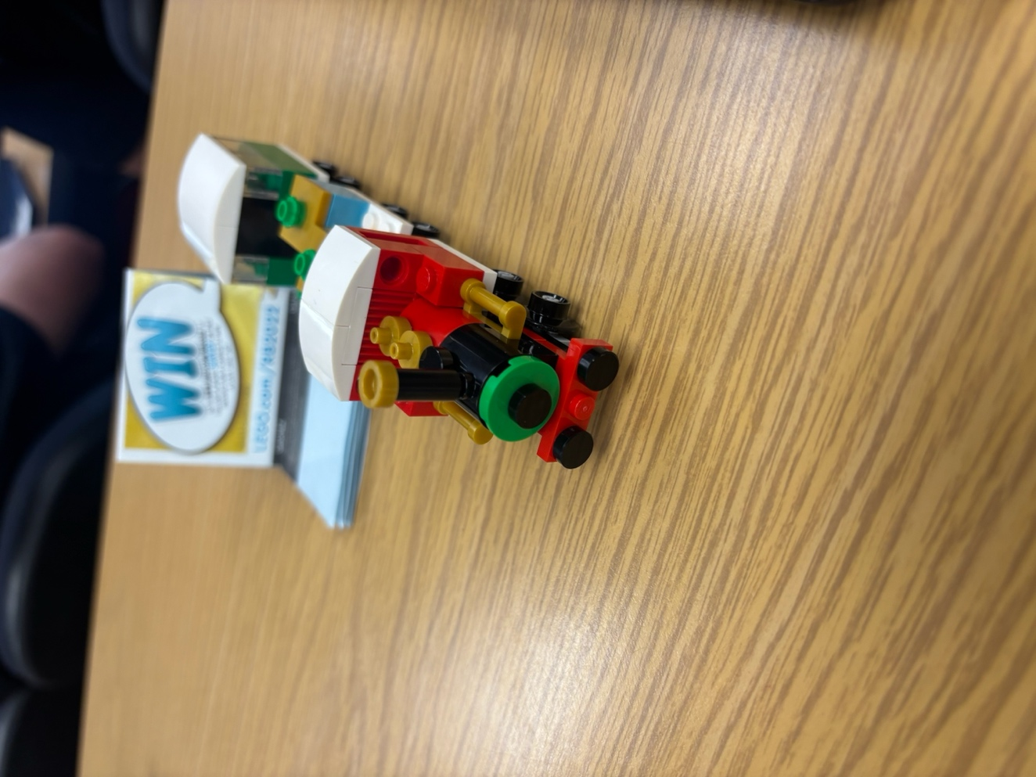
- Did you know what you were going to build before you built it? How did you know?
I did know what I was going to build before I built it as I saw in the instructions the image of the completed design. I also saw the image in the Legos packaging the pieces came in.
- Was the "design document" sufficient instruction to successfully build the project? Why?
The “design document” was sufficient instruction to successfully create the build as it described how to place the different Lego pieces together. Overall it was a smooth process building the train.

